Experiment-1

Configuration of Network Devices using Packet Tracer (Hub, Switch, Ethernet, Broadcast)

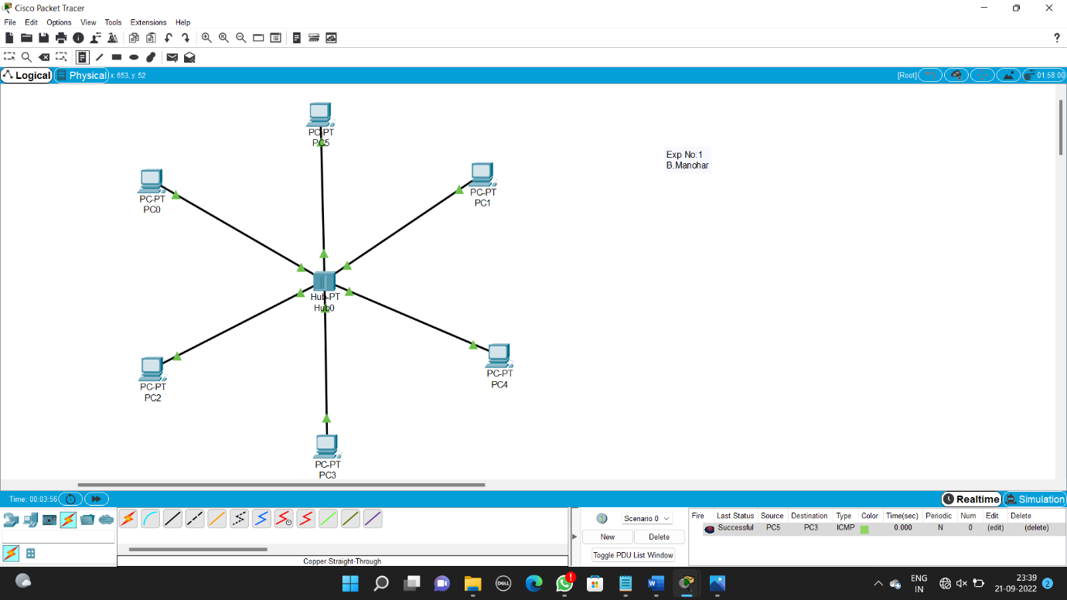

Experiment-2

Configuration of Topologies using Packet Tracer (Star, Mesh, Tree,)

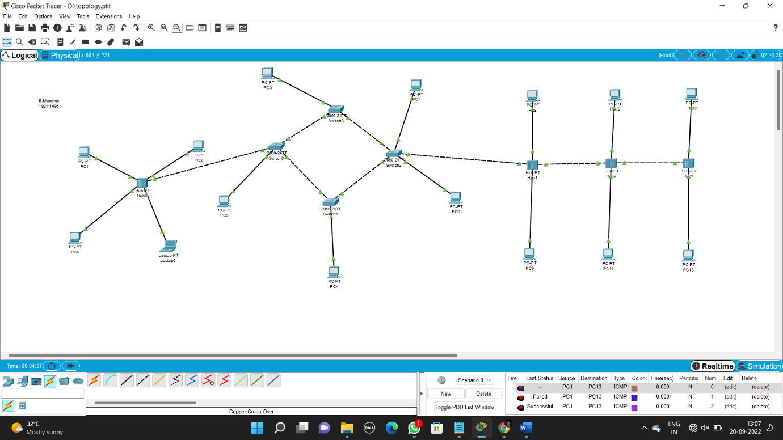

Experiment-3

Configuration of Topologies using Packet Tracer (Bus, Ring, Hybrid).

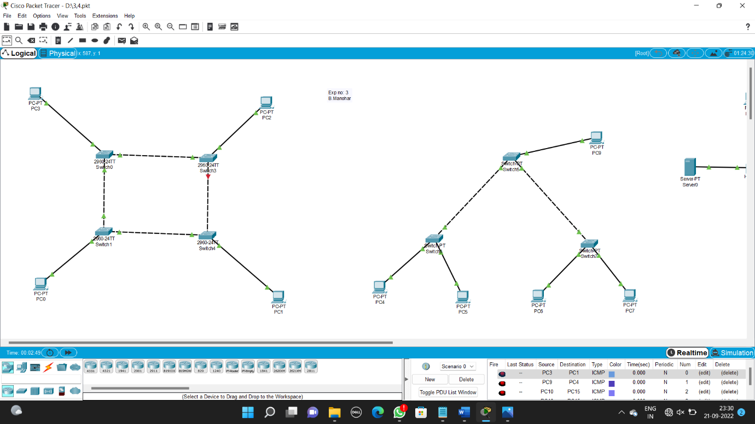

Experiment-4

Data Link Layer Traffic Simulation using Packet Tracer Analysis of CSMA/CD& CSMA/CA

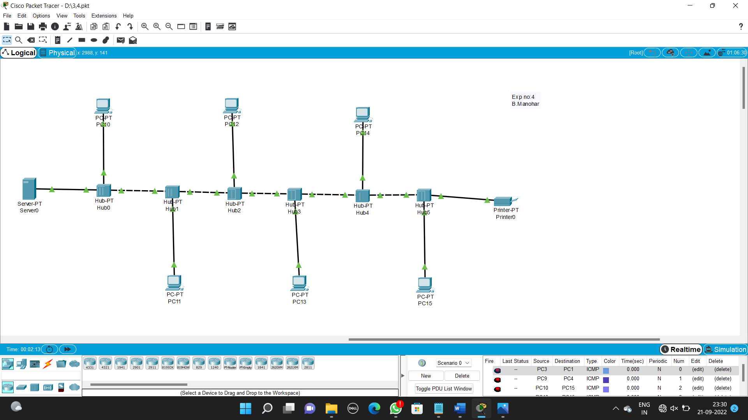

Experiment-5

Data Link Layer Traffic Simulation using Packet Tracer Analysis of ARP

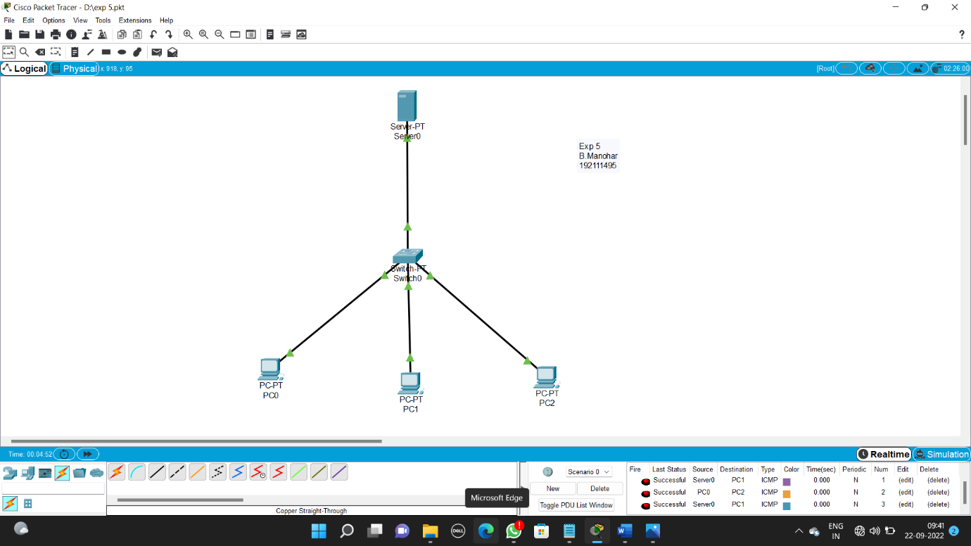

Experiment-6

Static Routing using Packet Tracer.

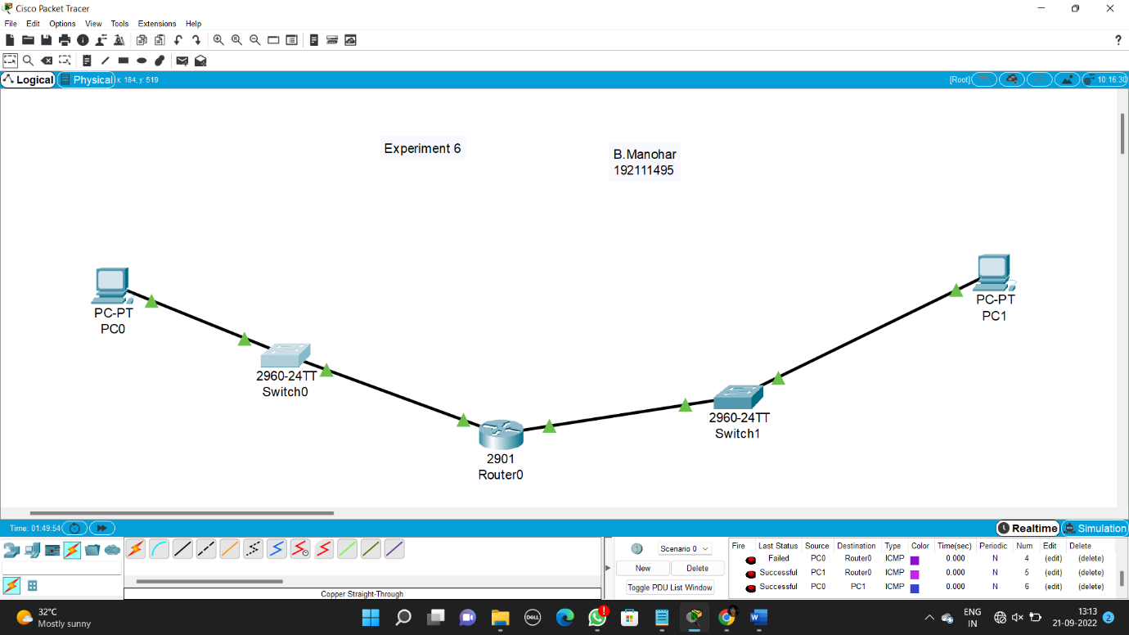

Experiment-7

Dynamic Routing using Packet Tracer ( OSPF)

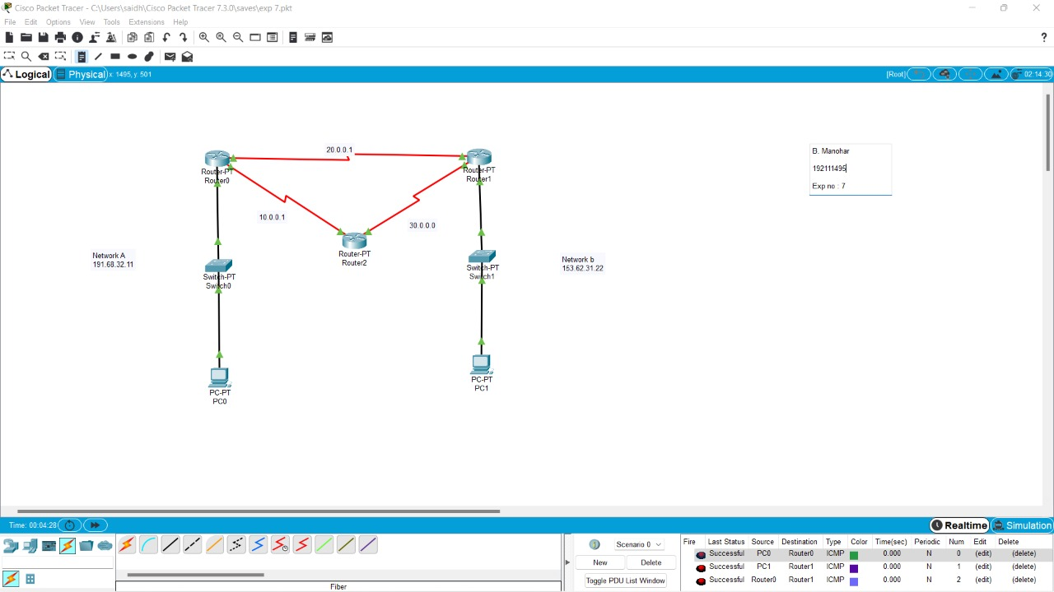

Experiment-8

Subnetting – Class C Addressing

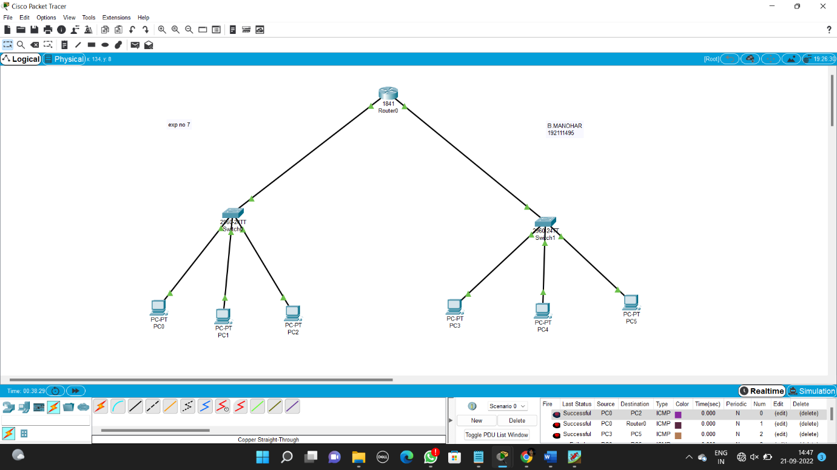

Experiment-9

Functionalities of TCP, UDP

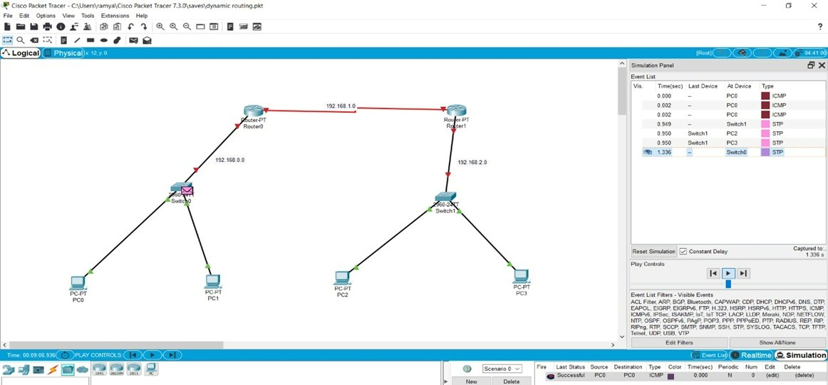

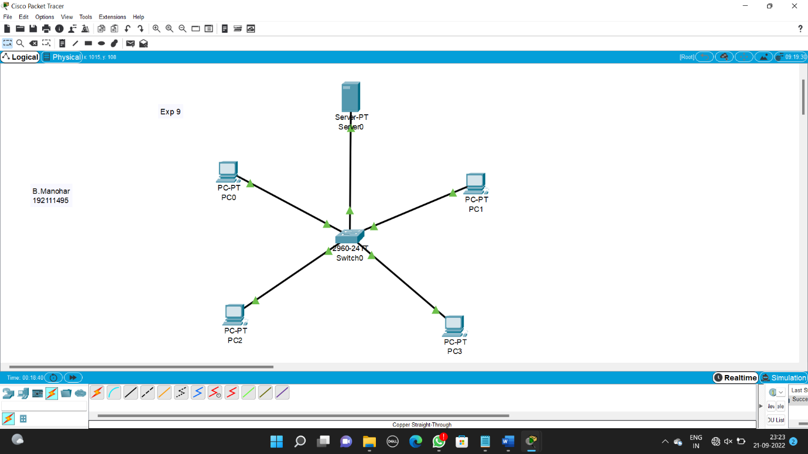

Experiment-10

TCP, UDP Exploration Solution



Experiment-11

IOT Based Smart Home Using Cisco Packet Tracer

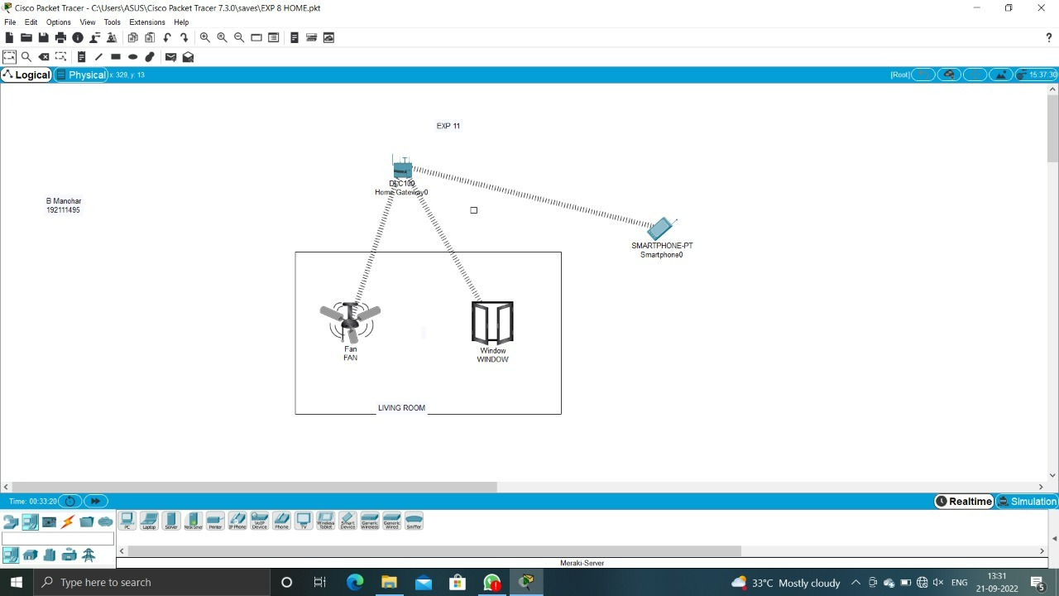

Experiment-12

Smart Garden in Cisco Packet Tracer

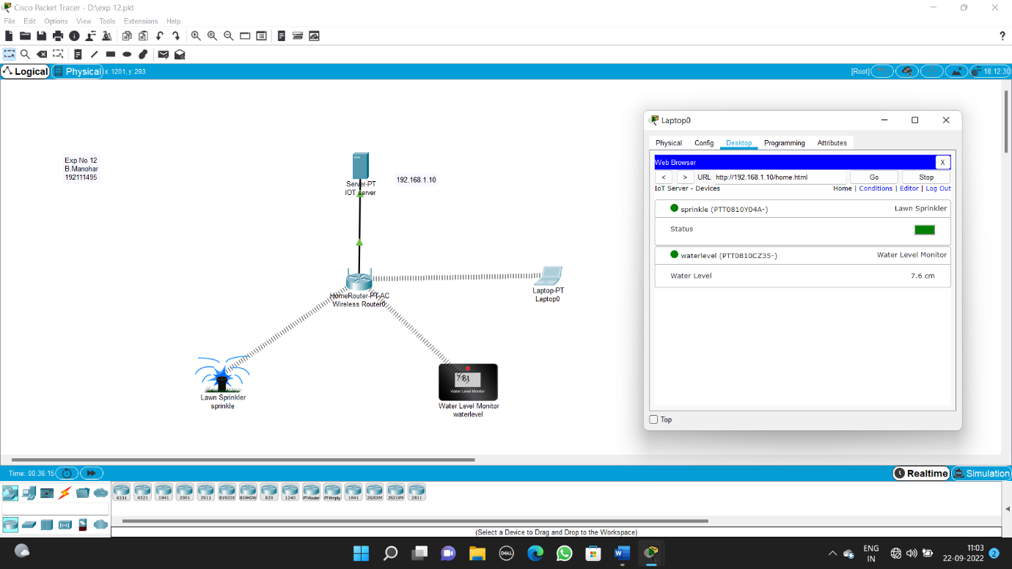

Experiment-13

IOT Devices in Networking Using Cisco Packet Tracer

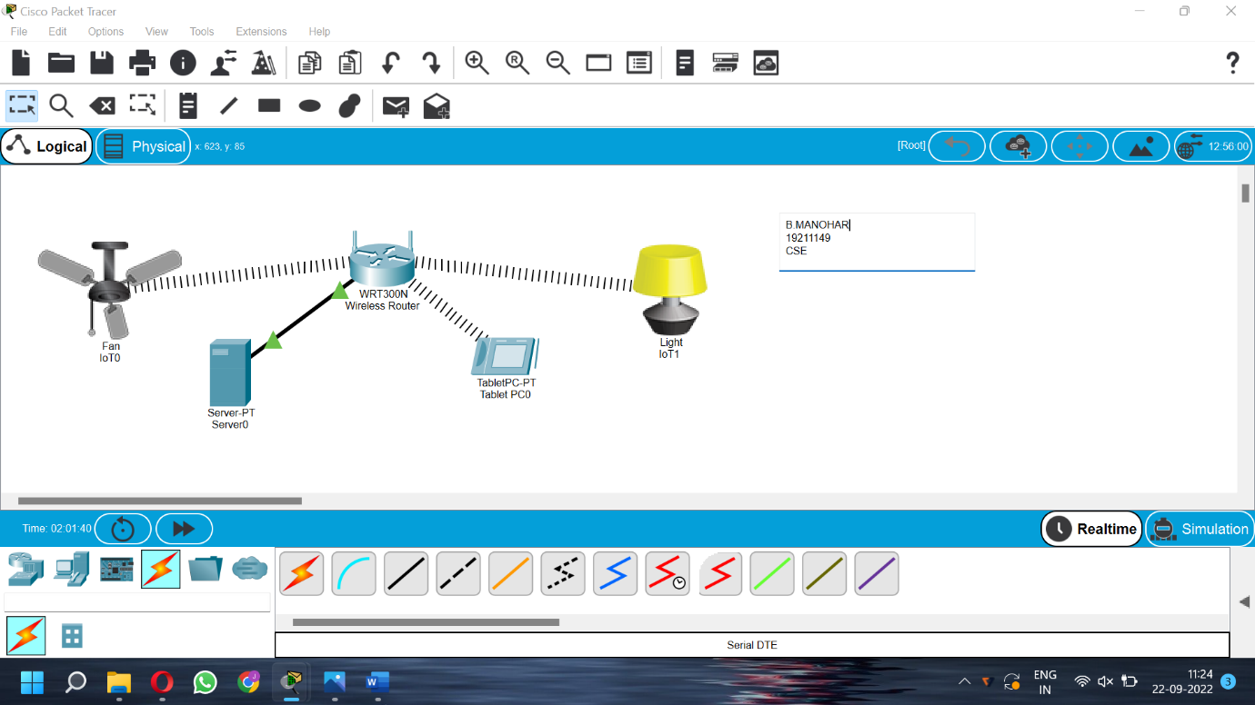

Experiment-14

Simulating X,Y,Z Company Network Design

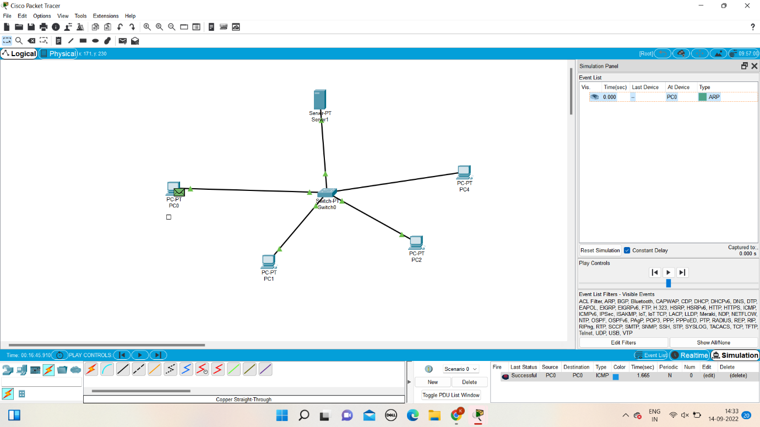

Experiment-15

Make Computer Lab in Cisco Packet Tracer

